PMS/PMDD
A 27-year-old, G0P0, with history of menarche at age 12, dysautonomia under treatment with buproprion, seeks evaluation for mood changes toward the end of her menstrual cycle. She feels increasing irritability with her friends and family, increased anxiety and depression, and lack of concentration. She just doesn’t “feel herself” and it is affecting her relationships and career. A few days after menstruation, she feels great relief from these symptoms and “more like herself”. She is wondering what is causing this and what she can do to find more “balance”.

- What additional information do you want to assess and determine on the physical exam?
History (Casanova et al., 2024; Yonkers & Casper, 2024):
- Age of menarche is known.
- When was the last menstrual period, length of periods, cycle length, and regular?
- Any family history of PMS or PMDD in the family?
- Any recent changes in periods, irregular bleeding, intermenstrual bleeding, postcoital bleeding?
- Onset, duration, and type of symptoms she has been experiencing specifically?
  - PMS: Mood lability, PHQ-9, angry outbursts, irritability, GAD-7, confusion, social withdrawal, abdominal bloating, fatigue, breast tenderness, headache, and extremity swelling.
    - Relieved within 4 days of the onset of menses, without recurrence until at least cycle day 13. Occur reproducibly during 2 cycles of prospective recording. Also, suffers from dysfunction in social or economic performance.
  - PMDD: DSM-5 criteria
    - One or more of the following must be present:
      - Mood swings, sudden sadness, increased sensitivity to rejection
      - Anger, irritability
      - Sense of hopelessness, depressed mood, self-critical thoughts
      - Tension, anxiety, feeling on edge
    - Plus, one or more of the following symptoms must be present to reach a total of five symptoms overall:
      - Difficulty concentrating
      - Change in appetite, food cravings, overeating
      - Diminished interest in usual activities
      - Easy fatigability, decreased energy
      - Feeling overwhelmed or out of control
      - Breast tenderness, bloating, weight gain, or joint/muscles aches
      - Sleeping too much or not sleeping enough
- Sexual history with partners, preference, behaviors, and contraceptive history?
- OB history is known.
- Do you use any drugs or alcohol? If so, how much, how often, what kind? Do you turn to a substance for coping?
- History of anxiety, depression, or other psychiatric disorders?
- Decreased interest in usual activities?
- Hypersomnia or insomnia? Food cravings?
- Any physical symptoms like breast tenderness or swelling, headaches, joint or muscle pain, bloating, or weight gain?
Physical (Casanova et al., 2024; Yonkers & Casper, 2024):
- Perform a standard ROS and physical.
- No definitive physical exam will aid in the diagnosis.
- What diagnostic studies could be helpful?
The diagnosis of PMS or PMDD is made based on the onset of cyclic symptoms that match specific criteria and by exclusion of other specific pathology (Casanova et al., 2024). After a detailed menstrual and symptom history has been taken, a review of labs, such as a complete blood count (CBC) to rule out anemia and thyroid stimulating hormone (TSH) to rule out thyroid disease, should be obtained (Casanova et al., 2024).

If this was a case of irregular menses, investigating the etiology is recommended. If irregular menses is noted, serum human chorionic gonadotropin (hCG), prolactin, and follicle-stimulating hormone (FSH) are added (Yonkers & Casper, 2024).

Outside of laboratory evaluation, the patient should be asked to track and record for two months her symptoms with the prospective monitoring with self-rating scale (displayed below). This will help determine when she is experiencing the symptoms in her cycle and confirm if she is symptom-free during the follicular phase, which is required for diagnosis. Lastly, any mood disorder, such as dysthymic or major depressive disorders, should be ruled out (Yonkers & Casper, 2024).

- What are your differentials and how would you explain these to the patient?
- PMS or PMDD
  - Premenstrual syndrome (PMS) is when there are physical and mood changes days before your period that affect parts of your normal life, and then resolves with your period. Premenstrual dysphoric disorder (PMDD) is a severe form of PMS when there are 5+ symptoms of PMS affecting aspects of your life.
- Depression and/or anxiety
  - Sometimes, PMS or PMDD can have similar symptoms of a down or anxious mood. It would be important for us to rule out any underlying anxiety or depression. Would you be willing to complete this PHQ-9 and GAD-7 form to get a better understanding?
- Thyroid disorder
  - Another component that would be a cause of your symptoms is an under or over-active thyroid. The thyroid is an important gland that makes and releases certain hormones, and when those are off, it can cause some of what you are describing. So, it would be important to check a TSH to assess the thyroid function. If you are okay with this lab, I will place an order.
- What is your plan of care for each of these, including pharmacological and non-pharmacological interventions?
- PMS and/or PMDD (Kalamarides, n.d.; Rakel & Minichiello, 2023; Yonkers & Casper, 2024)
  - Plan of care: Will be patient-centered based on life goals and rule out of other etiologies.
    - Nonpharmacological:
      - Lifestyle interventions: adequate hydration, diet, exercise, improved sleep, restraint from substance use, meditation, yoga, and cognitive behavioral therapy (CBT).
      - Period tracking for the next 2 cycles.
      - Supplement Options:
        - Calcium with Vit D: Ca+ - 600-1200 mg per day depending on dietary calcium intake. D3 – 600-1000 IU per day.
        - Magnesium: 200-400mg per day.
        - Inositol: 12 g per day. Use with caution when prescribing antidepressant or antianxiety medications.
        - Chaste Extract: 20-40mg per day.
        - Curcumin: Add spice to food or take in capsule.
    - Pharmacological:
      - Continue bupropion at current dose.
      - Start sertraline at 25mg daily.
    - Follow-up: Office or telemed visit in 4-6 weeks for pharmacological intervention. Office visit in 9-11 weeks for period tracking.
- Depression and/or anxiety (Craske & Bystritsky, 2024; Rush, 2024)
  - Plan of care: Will be patient-centered from PHQ-9 and GAD-7 results.
    - Nonpharmacological:
      - Lifestyle interventions with diet, exercise, improved sleep, restraint from substance use, meditation, yoga, and cognitive behavioral therapy (CBT).
    - Pharmacological:
      - Continue bupropion at current dose.
      - SSRIs or SNRIs are first-line.
  - Follow-up: Office or telemed visit in 4-6 weeks.
- Thyroid disorder
  - Plan of care: TSH reflex lab and treatment will depend on results.
    - Normal results: No intervention
    - Hypothyroidism: Levothyroxine daily & redraw TSH in 6-8 weeks.
    - Hyperthyroidism: Atenolol 25-50 mg daily if experiencing hyperadrenergic symptoms. Treatment will depend, but the goal should be radioactive iodine therapy or surgery.
  - Follow-up: TSH lab in 6-8 weeks.
- How does fertility awareness and cycle charting aid in detecting the signs of premenstrual syndrome (PMS) and premenstrual dysphoric disorder (PMDD).
The etiologies of PMS and PMDD are poorly understood, but the symptoms are thought to be cyclic changes in luteal phase hormones (Kalamarides, n.d.). Because of this hormonal fluctuation, fertility awareness and cycle charting aid in detecting the signs of PMS and PMDD by identifying the peak day and the actual day of ovulation. In the Creighton Model System (CrMS), the peak day is the last observed day of clear, stretchy, and/or lubricated cervical mucus (Kalamarides, n.d.). Identifying this mucus allows practitioners to time progesterone and estradiol hormone testing at peak days +3, 5, 7, 9, and 11 versus the traditional cycle day 21 lab draw.

Identifying the actual day of ovulation allows practitioners to offer therapies timed with the natural female cycle. Cooperative therapies offered are as follows (Kalamarides, n.d.):
- Progesterone 200mg capsule by mouth starting daily at bedtime on peak day +3 to peak day +12 (10 days in a row).
- Progesterone 300mg capsule vaginally daily at bedtime on peak +3 to peak +12.
- hCG 2,000 IU daily on peak day +3, 5, 7, and 9.
- Naltrexone 50mg (max) daily or low dose naltrexone (LDN) 4.5mg daily.
- What are current treatment guidelines for PMS and PMDD by healthcare professionals?
Treatment guidelines for PMS and PMDD by healthcare professionals are both nonpharmacological and pharmacological. Plus, a continuation of prospective charting of symptoms is recommended to assist in managing symptoms. “Symptoms may become more tolerable as the patient acquires an improved understanding of the physiology and pathophysiology occurring across her menstrual cycle” (Casanova et al., 2024, p. 419). Not to mention that continued monitoring may even help to determine if further focused therapy would be beneficial.

Nonpharmacological interventions are thought to help with the overall health of the body. Unfortunately, there is no clinical evidence suggesting these interventions significantly improve PMS and PMDD (Casanova et al., 2024).
- A diet focused on fresh rather than processed foods.
  - Increased fruits and vegetables & minimized intake of refined sugars and fats.
  - Minimize salt intake – may help with bloating.
  - Eliminate caffeine and alcohol – may reduce irritability and anxiety.
- Aerobic exercise – increases the endogenous production of endorphins.
- Supplements:
  - Calcium carbonate – decreases water retention, food cravings, pain, and negative affect compared with placebo.
  - Magnesium – involved in the proper function of nerves and muscle, blood sugar regulation, blood pressure, and heart rhythm.
  - B6 has limited clinical benefit – Not to exceed 100 mg/day.
- Studied but conflicting results or lack of research:
  - Vitamin E and D.
  - Chaste tree berry extract and evening primrose oil.
  - Therapies like relaxation, cognitive, and light.
  - Eastern therapies: Mediation, aromatherapy, reflexology, acupuncture, acupressure, and yoga.

Moving on to pharmacological treatments and guidelines. Interventions are broken out into mild and moderate to severe symptoms, and recommendations are noted as follows (Casper & Yonkers, 2024):
- Mild symptoms (do not cause distress, economic dysfunction, or social dysfunction):
  - Exercise and stress reduction.
  - Vitex agnus castus – herbal remedy – 20-40 mg of vitex extract daily.
  - Fluoxetine 10mg by mouth daily (adjust as needed).
- Moderate to severe symptoms (when criteria for PMS or PMDD are met, including economic or social dysfunction):
  - Cognitive behavioral therapy or pharmacologic interventions.
    - Two main approaches with the algorithm below (some women may require both):
      - SSRIs work to target the serotonin system by increasing the central serotonergic transmission. This intervention has the best evidence for efficacy and is recommended when contraception is not a high priority.
      - Combined oral contraception works to suppress the hypothalamic-pituitary-ovariana axis and ovulation. Monophasic, drospirenone (DRSP)-containing combined oral contraceptives (COCs) or gonadotropin-releasing hormone (GnRH) agonists. Typically reserved for women with severe symptoms that are non-responsive to other treatments.
        - Start with 3mg DRSP/20mcg ethinyl estradiol (EE) daily and increase, if needed, to 30mcg EE.
        - If not controlled, trial hormonal COC.
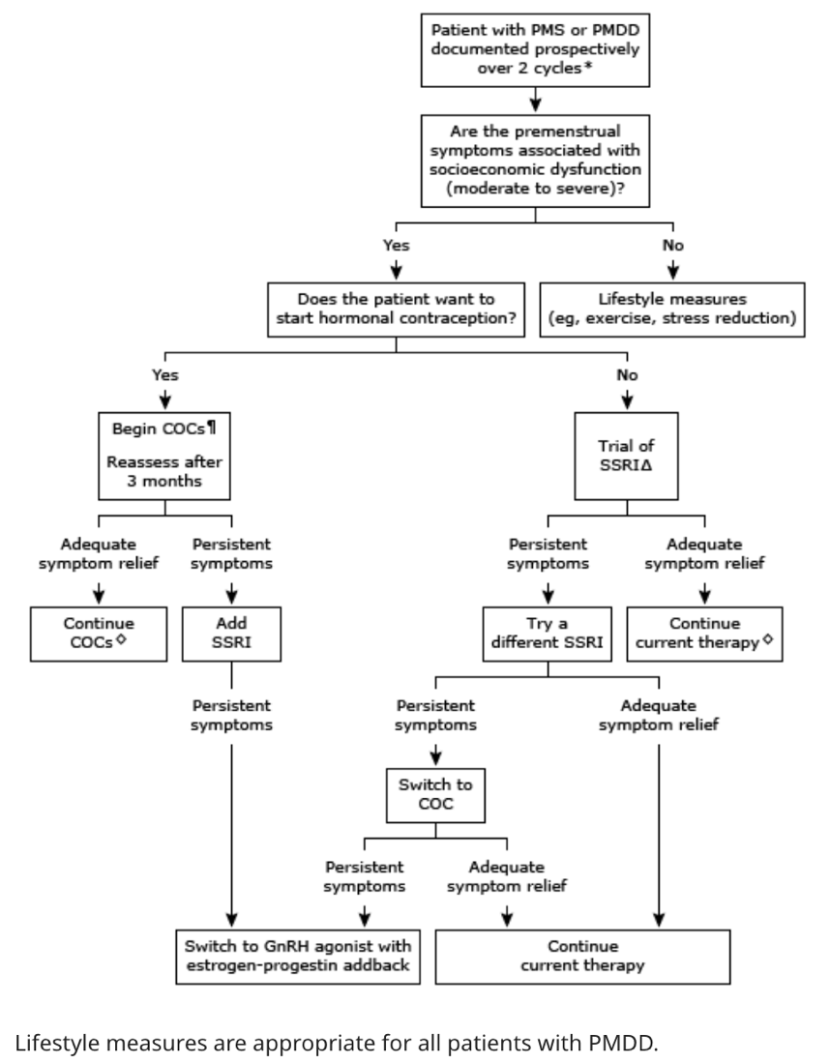
- What treatment options exist if the patient declines synthetic hormones (birth control)?
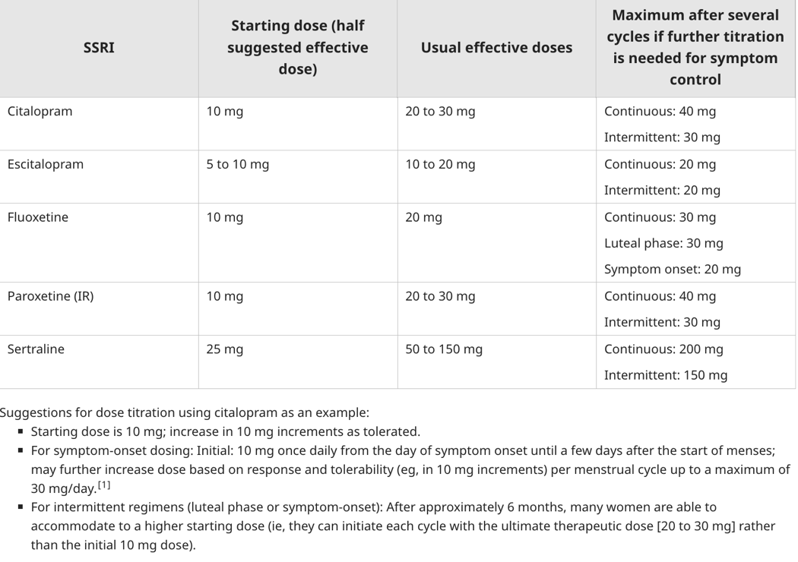
If the patient declines synthetic hormones, clinical evidence points to SSRIs for symptom management. The following chart depicts the medications and dosing recommendations (Casper & Yonkers, 2024):

The SSRIs can be administered in three ways:
- Continuous – recommended with low-level symptoms present during non-premenstrual intervals, with severe physical symptoms, or for convenience and simplicity.
- Luteal phase – Starts on cycle day 14 and discontinued at the onset of menses or continued for several additional days with a history of persistent symptoms during menses. It is important to know that the patient is asymptomatic during the follicular phase, otherwise she will be undertreated. Lastly, higher doses may be needed to treat physical symptoms adequately.
- Symptom-onset – Starts at the point of symptoms onset until the first few days of menses.

If SSRIs are not tolerated, there is an option to use venlafaxine (SNRI) or clomipramine (tricyclic antidepressant).

Another option for treatment is rooted in fertility-based awareness. This option would require the CrMS training, and the patient must be willing to track her cycles for at least two months. As noted above, cooperative therapies offered are as follows (Kalamarides, n.d.):
- Progesterone 200mg capsule by mouth starting daily at bedtime on peak day +3 to peak day +12 (10 days in a row).
- Progesterone 300mg capsule vaginally daily at bedtime on peak +3 to peak +12.
- hCG 2,000 IU daily on peak day +3, 5, 7, and 9.
- Naltrexone 50mg (max) daily or low dose naltrexone (LDN) 4.5mg daily.
- What are the benefits and risks to these treatment options?
Benefits:
- SSRIs (Caspers & Yonkers, 2024)
  - Symptoms relief is expected in the first cycle.
  - Option to increase dosing in subsequent cycles, if needed.
  - 3 regimen options.
  - Option for treating mood symptoms.
- COC (Caspers & Yonker, 2024)
  - Option for wanting birth control.
  - Option to increase dosing in subsequent cycles, if needed.
- Naltrexone (Kalamarides, n.d.)
  - Showed a significant reduction in symptoms based on the Mean Distress Questionnaire.
Risks:
- SSRIs (Caspers & Yonkers, 2024)
  - 30-40 percent do not respond to intervention.
  - Side effects are dose-dependent but may include nausea, headache, insomnia, and decreased libido.
  - Sudden treatment discontinuation can lead to discontinuation symptoms such as dizziness, ringing of the ears, and “body shocks.”
- COC (Caspers & Yonkers, 2024)
  - Worsening mood.
  - DRSP may be associated with a higher risk of venous thromboembolism (VTE).
- Naltrexone (Kalamarides, n.d.)
  - Dizziness, fatigue, nausea, headache
  - LDN – vivid dreams for 7 days, less effective in treating PMS then higher doses

Supplemental Readings:
Hofmeister S, Bodden S. “Premenstrual Syndrome and Premenstrual Dysphoric Disorder.” Am Fam Physician. 2016;94(3):236‐240.

Hilgers, Thomas W. “The New Women’s Health Science of NaProTechnology.” Archives of Perinatal Medicine 17 no. 4 (2011): 191-198.

References:
Casanova, R., Goepfert, A. R., Hueppchen, N., Weiss, P. M., & Connolly, A. (2024). Beckmann and Ling’s obstetrics and gynecology (9th ed.). Wolters Kluwer.

Casper, R. F., & Yonkers, K. A. (2024, April 20). Treatment of premenstrual syndrome and premenstrual dysphoric disorder. UpToDate. Retrieved on January 24, 2025 from https://www-uptodate-com.ezproxy.umary.edu/contents/treatment-of-premenstrual-syndrome-and-premenstrual-dysphoric-disorder?search=pmdd&source=search_result&selectedTitle=2%7E22&usage_type=default&display_rank=2

Craske, M., & Bystritsky, A. (2024, March 28). Generalized anxiety disorder in adults: Management. UpToDate. Retrieved on January 25, 2025 from https://www-uptodate-com.ezproxy.umary.edu/contents/generalized-anxiety-disorder-in-adults-management?search=anxiety%20treatment&source=search_result&selectedTitle=1%7E150&usage_type=default&display_rank=1#H1557897358

Kalamarides, J. A. (n.d.). Targeted diagnosis and treatment for PMS with FABMs [PowerPoint slides]. FACTS About Fertility. https://www.factsaboutfertility.org/topic/premenstrual-syndrome-pms-umary/

Rakel, D., & Minichiello, V. J. (2023). Integrative medicine (5th ed.). Elsevier.

Rush, A. J. (2024, August 6). Major depressive disorder in adults: Approach to initial management. UpToDate. Retrieved on January 25, 2025 from https://www-uptodate-com.ezproxy.umary.edu/contents/major-depressive-disorder-in-adults-approach-to-initial-management?search=depression%20treatment&source=search_result&selectedTitle=2%7E150&usage_type=default&display_rank=2

Yonkers, K. A., & Casper, R. F. (2024, April 30). Clinical manifestations and diagnosis of premenstrual syndrome and premenstrual dysphoric disorder. UpToDate. Retrieved on January 24, 2025 from https://www-uptodate-com.ezproxy.umary.edu/contents/clinical-manifestations-and-diagnosis-of-premenstrual-syndrome-and-premenstrual-dysphoric-disorder?search=pmdd&source=search_result&selectedTitle=1%7E22&usage_type=default&display_rank=1#H287511

