Personal Leadership Development Plan

Christina Hoff
University of Mary
NUR 614: Resilient Nursing Leadership
Dr. Joanne Lassiter
August 6, 2023

Personal Leadership Development Plan
Leadership is identified by vision, motivation, experience, and the ability to navigate endless change while influencing teams to perform to their highest potential. A quality leader is passionate about the path being followed and has authenticity and authority guided by agapé. Understanding leadership, as it applies to professional competencies, is crucial for the growth and development of leadership skills, as well as being open to feedback from intra- and interdepartmental peers. As a developing leader, utilizing 360-leadership evaluation tools (including a self-assessment evaluation) to develop a leadership development action plan will serve as a roadmap to goal achievement. In addition, the evaluation tool and action plan will help leaders bring personal and professional growth to fruition while maintaining a leadership philosophy applicable to the leadership journey.
Leadership Competency
Leadership is a challenging yet rewarding role to occupy. One component is the ability to exercise creativity while inspiring creativity and drive in others. Leadership is always focused on making the whole better than it was (Porter-O’Grady & Malloch, n.d.). With that in mind, successful leaders have core competencies that influence their success. Core competencies essential for high-quality, effective leadership revolve around leading self, the organization or department, and others (SHRM, 2008). One concept to remember is that each position may require different competencies to succeed (SHRM, 2008).
Nurse practitioners are uniquely positioned to participate in leadership opportunities within the macro-, meso-, and micro-levels of served communities and organizations. The National Organization of Nurse Practitioner Faculties (NONPF) has defined core competencies essential to the role of a nurse practitioner. These competencies, listed in Table 1, define essential behavior upon entry to the profession for all nurse practitioners, regardless of population focus (NONPF, n.d.).
Table 1. NONPF Nurse Practitioner (NP) Role Core Competencies
Domain | Description
Domain 1: Knowledge of Practice | Integration, translation, and application of established and evolving scientific knowledge from diverse sources as the basis for ethical clinical judgment, innovation, and diagnostic reasoning.
Domain 2: Person-Centered Care | Uses evidence-based and best practices to design, manage, and evaluate comprehensive person-centered care that is within the regulatory and educational scope of practice.
Domain 3: Manage Population Health | Provide care across the continuum in partnership with public health, healthcare systems, community, academic community, governmental, and other entities to integrate foundational NP knowledge into culturally competent practices to increase health promotion and disease prevention strategies to care for the populations.
Domain 4: Practice Scholarship and Translational Science | Generates, appraises, synthesizes, translates, integrates, and disseminates knowledge to improve person-centered health and systems of care.
Domain 5: Quality and Safety | Utilizes knowledge and principles of translational and improvement science methodologies to improve quality and safety for providers, patients, populations, and systems of care.
Domain 6: Interprofessional Collaboration in Practice | Collaborates with the interprofessional team to provide care through meaningful communication and active participation in person-centered and population-centered care.
Domain 7: Health Systems | Demonstrates organizational and systems leadership to improve healthcare outcomes.
Domain 8: Technology and Information Literacy | Envisions, appraises, and utilizes informatics and healthcare technologies to deliver care.
Domain 9: Professional Acumen | Demonstrates the attributes and perspectives of the nursing profession and adherence to ethical principles while functioning as a committed equal partner of the interprofessional health care team.
Domain 10: Personal and Professional Leadership | Participates in professional and personal growth activities to develop a sustainable progression toward professional and interpersonal maturity, improved resilience, and robust leadership capacity.
 | (NONPF, 2022)
While all the domains have components of leadership, the parts specific to leadership are six (interprofessional collaboration in practice), seven (health systems), nine (professional acumen), and ten (personal and professional leadership). In practice, domain six, interprofessional collaboration is a partnership across teams to ensure patient-centered care. This collaboration requires high levels of communication, honesty and transparency, the ability to partner and promote teamwork, build relationships, analyze circumstances, and solve problems. Domain seven, health systems, relates to action by integrating domain six and considering cost-effectiveness with care and optimization through innovation and evidence-based practice. Professional acumen, domain nine, ties together the practice and ethical principles of the nursing profession to function as an equal partner of the interprofessional healthcare team (NONPF, 2022). Professional acumen takes knowledge, professionalism, vulnerability, grit, and resilience to maintain identity, ethics, diversity, and inclusion for patient-centered care. Domain ten, personal and professional leadership, is a commitment to personal health and well-being, professional maturity, and a continued capacity for leadership and leadership growth.
360 Evaluation: Leadership Evaluation Tool
Surviving and thriving in a complex adaptive system (CAS) takes growth and development to a new level. With teamwork, employee development, and customer service being the focus of a CAS, feedback has shifted from intradepartmental to interdepartmental (United States Performance Office of Management, 1997). Feedback, with positive intent, from various departments and operational levels, along with a self-assessment, is required for a 360-degree evaluation and implementation of a development plan. The leadership evaluation tool used in this author’s assessment was the nursing leadership evaluation tool supplied by the University of Mary’s Resilient Nurse course.
In the context of the leadership evaluation tool, five individuals were selected from within the Family Medicine and Integrative Medicine departments. The surveys were distributed to two licensed practical nurses (LPNs), two physicians, and the nursing manager. When the leadership evaluation tool was given to the participants, an envelope accompanied it, and verbal instructions were given for the evaluation. The participants were requested to speak honestly to support the growth and development of this author’s leadership skills. The survey consisted of seventeen questions with a Likert scale of not applicable (N/A) to one through five ratings; one representing ‘never,’ two ‘seldom,’ three ‘sometimes,’ four ‘usually,’ and five ‘almost always.’ The final part of the survey had three open-ended questions, ‘This person can do more of…’, ‘This person can do less of...’, and ‘Additional comments.’ A copy of the evaluation can be found in the appendices. Appendix A is a completed evaluation with the mean scores noted from the individuals listed above, and Appendix B is a completed self-evaluation.
Method of Confidentiality
Confidentiality is crucial when it comes to 360-degree assessments. Without privacy, an honest evaluation may not be given, and growth might be stunted. As suggested in the syllabus, one individual was selected to receive the completed surveys and collate the results. Andy Larson, Director of Family Medicine in Fargo, was this person. Larson received the surveys in a sealed envelope, then de-identified the surveys by completing a new survey with the calculated mean for each question. The comments associated with the surveys were typed in the Word document. The information in the survey was then given to this author to review.
Leadership Evaluation
As stated above, five surveys were distributed to individuals of various roles and between two departments; four were completed and returned. A copy of the survey with mean scores, along with the associated comments noted in the open-ended questions, is depicted in Appendix A. According to peers, the most significant areas of opportunity are facilitating the constructive resolution of conflict (mean score of 4.25); knowledge of principal drivers of department revenues and reimbursement, expenses, and profits when making decisions affecting the department or project (mean score of 4.3); and closely monitoring ongoing department indicators which affect unit financial performance (mean score of 4.3).
The comments associated with the open-ended questions resonated with messages related to overall performance and constructive suggestions for improvement. Comments related to overall performance were as follows:
- “Tina is an excellent leader and a role model of one. I appreciate that she [Tina] is receptive to our feedback and that she [Tina] pressures us to have the freedom of managing ourselves instead of always directly delegating.”
- “Tina has been a wonderful asset to Family Medicine.”
- “An exceptional person with a kind, positive personality and perspective enriching the workplace, making it a place I enjoy working.”
Several opportunities for improvement were noted with positive intent and recommendations for the betterment of the whole. Comments associated with opportunities for improvement were as follows:
- “Rounding on staff-ensuring all are being productive, inquiring if each staff member needs help (sometimes we can be too busy or proud to ask for help).”
- “Self-care, trying not to overextend herself too much.”
- “At times, clinic is over-staffed for the ratio of providers in clinic.”
One recommendation was made for the question ‘This person can do less of:’
- “Overextending herself. She gets the job done but needs to say no too.”
Leadership Evaluation Reflection
The feedback noted in the 360-evaluation leadership tool helped identify areas of improvement that are needed for the teams I serve. These suggestions did not surprise me as I have noted struggles in these areas and have tried to be more cognizant of how my emotions, behavior, and organization impact the team. There are moments when I fall into a time trap and struggle with prioritization and procrastination. In addition, I am still working to balance upper leadership expectations with financial obligations and having adequate staffing and resources available to perform safe and effective procedures in a timely manner.
A perfect example of finding this balance is staffing one nurse with a provider who sees eighteen patients in one day with six procedures (including but not limited to LEEPs, colposcopies, and IUD insertions/removals) in twenty-minute slots and, at times, back-to-back. Amid this challenge, the clinic has experienced the procedure bed malfunctioning (during a procedure), leaking oil all over the floor, and requiring two staff to clean up. There have been issues with supplies being expired or absent altogether, requiring (in the moment) supply collaboration with other departments. Any unexpected event requires debriefing emphasizing safety and strategic planning to avoid the situations moving forward. This is where adaptability and resilience come into play. As a middle-management leader, I am in a position of de-escalating and motivating the nursing team, the providers, and the patients, all while working to meet the demands of a fixed budget and being emotionally and physically present in the moment.
As mentioned earlier, the feedback noted in the leadership evaluation helped identify areas of improvement. The comments and ratings from the evaluation tool will aid in developing my leadership action plan by allowing me to select the top three areas to work on. Focused priorities will guide the development of specific, measurable, attainable, reliable, and timely (SMART) goals necessary to promote personal and professional growth. Not to mention, having the goals noted within the context of a written development plan, I can revisit them during moments of reflection, and I can monitor my progress throughout the upcoming year.
Self-Assessment
While peer feedback is important, self-assessment and self-realization are just as critical. A self-assessment is taking the same evaluation tool and reflecting on how one views their performance related to the questions being asked. Completing the evaluation tool in this manner may provide insight and self-realization to performance or performance development. When a self-assessment is compared to peer assessments, gaps may be noted, and growth opportunities may present themselves. In the context of this leadership development plan, my completed Nursing Leadership Evaluation Tool is noted in Appendix B.
Upon review of the evaluation tool, I noted that, in most cases, I selected ‘usually’ (4) for performance related to accountability, conflict resolution, and meeting departmental performance standards. The rationale was that I do not feel I always complete the task promptly and feel I can continually improve. Currently, I struggle to meet the daily staffing-to-provider ratio due to fluctuations in volume and having staff available to complete the indirect patient care tasks. As for the questions I responded with ‘almost always’ (5); they related to people and supporting teamwork. I have a strong belief that to promote patient and occupational safety; it is essential for teams to have the resources necessary to do their job and to do it efficiently.
When I compared the findings from my self-evaluation to those from my peers, the questions I noted ‘almost always’ were in-line with that of my evaluators. My peers did note an ‘almost always’ selection to taking accountability to improve department performance and that I act promptly and decisively to address problems. The mean for the remaining questions fell between 4.3 and 4.75 and indicated areas of opportunity. This corresponds with my leadership assessments of being a benevolent ruler and campaigner (discussed later in this paper).
Professional Development Plan
Growth and development begin with discovering and knowing one’s strengths and opportunities. Successful leaders have personal and professional visions guiding their goals and careers. One way to achieve goals through growth and development is to create a detailed development plan to lay out key strategies and techniques to achieve the desired goals. According to IMD (2022), the development plan will provide greater overall career satisfaction, provide more exciting opportunities and challenges, and allow for a more impactful career.
When reaching out to implement a development plan, I investigated my strengths and opportunities to create action. First, I returned to self-assessment findings on strengths and emotional intelligence from when I earned my Bachelor of Science in Nursing (BSN). According to Strengthsfinder 2.0 (Rath, 2007), my top strengths were adaptability, restorative, futuristic, woo, and communication. When I completed the Emotional Intelligence (EI) 2.0 survey (Bradberry & Greaves, 2009), it was determined that I needed to work on my personal and social competence with specific attention to self-awareness and relationship management.
When I compare the Strengthsfinder and EI results to the leadership assessments completed in Resilient Leadership, my strengths and opportunities played a role. The main themes in my leadership assessments were a free spirit and an idealistic social dreamer who wants everyone to be happy (16Personalities, n.d.; Kingdomality, n.d.; Leadership diamond assessment, n.d.). The above traits provide an opportunity to develop my vision, organization, courage, and reality. This was spot on, with all five of my strengths and the opportunities noted with EI. Details of the assessments are found in Table 2.
Table 2. Leadership Assessments
Assessment | Description
Strengthsfinder 2.0  (taken in 2021) | Adaptability: Live in the moment. The future is not a fixed destination; it is created out of the choices made now. Enables response to demands in the moment while still remaining productive.  Restorative: Loves solving problems. Enjoys the challenge of analyzing the symptoms and finding a solution.  Futuristic: Loves to peer over the horizon. “Wouldn’t it be great it…”  Woo: Works to win others over.  Communication: Like to explain, to describe, to host, to speak in public, and to write.
Emotional Intelligence 2.0 (taken in 2021) | Personal Competence: Self-awareness – 60; Self-management – 77  Social Competence: Social awareness – 77; Relationship management – 67  Opportunities for growth: appreciating the impact my behavior has upon others, trouble understanding my emotions, and not owning up to my shortcomings.
Diamond Leadership | Ethics: 4.5; Vision: 4.3; Courage: 4.3; Reality: 4.3  High regard for and sensitivity to people in general and as individuals. Value emotional sensitivity, personal loyalties, friendship, and intimacy. Concerned with the treatment of people and tend to be compassionate and helpful.  The greatest opportunity for growth is vision, courage, and reality.
The Personal Preference Profile Test | The Benevolent Ruler.  Idealistic social dreamer. Overriding goal is to solve the people problems of my world. Perceptive of the woes and needs of humankind. Often have the understanding and skill to readily conceive and implement the solutions to my perceptions.
16 Personalities Test | Campaigner – ENFP-A  Strengths: Curious, perceptive, enthusiastic, excellent communicators, festive, and good-natured.  Weaknesses: People-pleasing, unfocused, disorganized, overly accommodating, overly optimistic, and restless.
(Bradberry & Greaves, 2009; 16Personalities, n.d.; Kingdomality, n.d.; Leadership diamond assessment, n.d.; Rath, 2007).

Future Leader
Personal and professional growth takes time to develop; it comes from mentoring, education, feedback, and experience. In the 360-leadership evaluation, the evaluators noted this author as an asset to the department, exhibiting traits of a role model by listening; offering kindness, positivity, and encouragement; being open to change; and allowing for independent decision-making. The calculated mean showed opportunities for growth in conflict resolution and understanding and monitoring the department indicators and financial obligations of the department.
Leadership is not a stagnant skill but a process of continuous reflection and growth. In five years, I hope evaluator feedback will note traits of authentic listening, empathy, attention to detail, ambition, and optimism. In addition, there would be improved conflict resolution, a better understanding of the organization's financial obligations, and the ability to motivate teams to achieve effective and productive outcomes.
Philosophy of Leadership
My leadership philosophy is leading through example, utilizing EI, encouraging thought diversity, and demonstrating ongoing education, adaptability, transparency, vulnerability, and resilience. Seeking to understand the bigger picture, creating a culture of trust, and connecting nursing and evidence-based practice to the organizational vision and mission. Leading with an intermingling of servant and transformational leadership principles that support growth and innovation. Overall, looking to meet the legitimate needs of the team, removing barriers, so they can serve the customer while working to create an improved system that allows the team to operate at their fullest potential (Albert et al., 2022; Hunter, 1998).
Leadership Development Action Plan
As previously stated, leaders must grow and develop to become high-quality influential leaders. One way to do this is by creating a detailed action plan that helps set goals and lays out key strategies and plans to achieve the goals. The leadership development action plan I have set for myself is outlined in Table 3.

Table 3. Leadership Development Action Plan
Focused Action Area | Planned Activity | Comments of Specifics re Activity | Anticipated Timeline: Start/Completion | Measurement of Achievement
Conflict Resolution | Reading, studying, & practice | Read Crucial Conversations by Patterson et al. (2002), Crucial Confrontations by Patterson et al. (2005), & work through Franklin Covey’s conflict resolution training. | Start: Immediately.  Completion: Crucial Conversations 12/31/23, Franklin Covey 12/31/23, Crucial Confrontations 6/30/24 | Measured by completion of reading books and mentorship feedback.
Department Indicators | Become familiar with quality indicators and dashboards | Work with my nurse manager and quality department to understand reports and dashboards important to the department. | Start: Immediately.  Completion: Meeting with my nurse manager by 8/31/23 and with quality department by 9/30/23. Monitoring of indicators is ongoing. | Measured by completion of meeting with nurse manager, quality department. Monthly monitoring of indicators and dashboards with updates to the team.
Financial Knowledge | Understand the department budget and financial spreadsheets.  Study the Medical Group Management Association (MGMA) staffing ratio algorithm. | Meet with my nursing manager, director, and financial advisor.  Review scholarly articles and MGMA website on staffing ratios. | Start: Immediately.  Completion: Meeting with team by 9/30/23.  Review of MGMA staffing by 10/31/23. | Measured by completion of meeting with team, and by meeting staffing production measures.
Accountability | Organize my emails and important information within a functionable and accessible format.  Respond to staff concerns promptly. | Create folders for emails and sort through messages that are a higher priority.  Always have a notebook with me to make notes when needed.  Encourage staff to email to requests to ensure follow up.  Open communication with staff on concerns and follow up. | Start: Immediately.  Completion: Ongoing. | Measured by completion of tasks and follow ups in a timely manner as indicated by a follow up 360-leadership evaluation and team feedback.
Physical Wellness | Go for a walk 3 times per week.  Use elliptical machine 3 times per week. | Walk with my spouse, Chris or alone.  On opposite days of the walk, use elliptical machine in basement. | Start: Immediately.  Completion: Ongoing. | Measured by completion of walk and elliptical efforts.
Spiritual Wellness | Attend church.  Practice meditation and mindfulness. | Attend church at least twice per month.  Practice meditation three times per week and practice mindfulness daily. | Start: Immediately.  Completion: Ongoing. | Measured by attendance and personal practice of meditation and mindfulness.
Mental Wellness | Practice self-compassion.  Practice meditation and mindfulness. | Participate in self-reflection and promote compassion daily.  Practice meditation three times per week and practice mindfulness daily. | Start: Immediately.  Completion: Ongoing. | Measured by completion of personal practice and promotion of self-reflection, compassion, meditation, and mindfulness.

Conclusion
Personal and professional growth and development takes time, commitment, and strategic planning. It requires an open mind and vulnerability to ask for feedback and create an action plan to enhance leadership skills to benefit the whole. There will be progression and setbacks along the way, but reflection on the written plan will help keep a clear direction. This semester has brought about advanced learning and viewpoints designed to boost an up-and-coming leader but also has given insight into change for experienced leaders. I am eager to see how the development plan unfolds over the next year and how my leadership skills evolve because of this purposeful action.

References
16Personalities. (n.d.). Free personality test. https://www.16personalities.com/free-personality-test
Albert, N., Pappas, S., Porter-O’Grady, T., & Malloch, K. (2022). Quantum leadership: Creating sustainable value in health care (6th ed.). Jones & Bartlett Learning.
Bradberry, T., & Greaves, J. (2009). Emotional intelligence 2.0. TalentSmart.
Hunter, J. C. (1998). The servant: A simple story about the true essence of leadership. Crown Publishing.
International Institute for Management Development [IMD]. (2022, April). 4 best ways to create leadership development plans. IMD Business School for Management and Leadership. https://www.imd.org/reflections/leadership-development-plans/#:~:text=A%20leadership%20development%20plan%20is,career%20growth%20and%20professional%20development.
Kingdomality. (n.d.). The personal preference profile test. https://kingdomality.com/
Leadership diamond assessment. (n.d.). http://www.pib.net/process.php
National Organization of Nurse Practitioner Faculties [NONPF]. (n.d.). NONPF’s NP Role Core Competencies. https://www.nonpf.org/page/NP_Role_Core_Competencies
National Organization of Nurse Practitioner Faculties [NONPF]. (2022). NONPF Nurse Practitioner Role Core Competencies Table. https://cdn.ymaws.com/www.nonpf.org/resource/resmgr/competencies/20220825_nonpf_np_role_core_.pdf.
Porter-O’Grady, T., & Malloch, K. (Host). (n.d.). Therapeutic leadership. [Video podcast].
Rath, T. (2007). Strengthsfinder 2.0. Gallup Press.
SHRM. (2008, March 1). Leadership competencies. SHRM. https://www.shrm.org/resourcesandtools/hr-topics/behavioral-competencies/leadership-and-navigation/pages/leadershipcompetencies.aspx#:~:text=Leadership%20competencies%20are%20leadership%20skills,2
United States Performance Office of Management. (1997, September). 360-degree assessment: An overview. https://www.opm.gov/policy-data-oversight/performance-management/performance-management-cycle/rating/360assessment.pdf

Appendix A
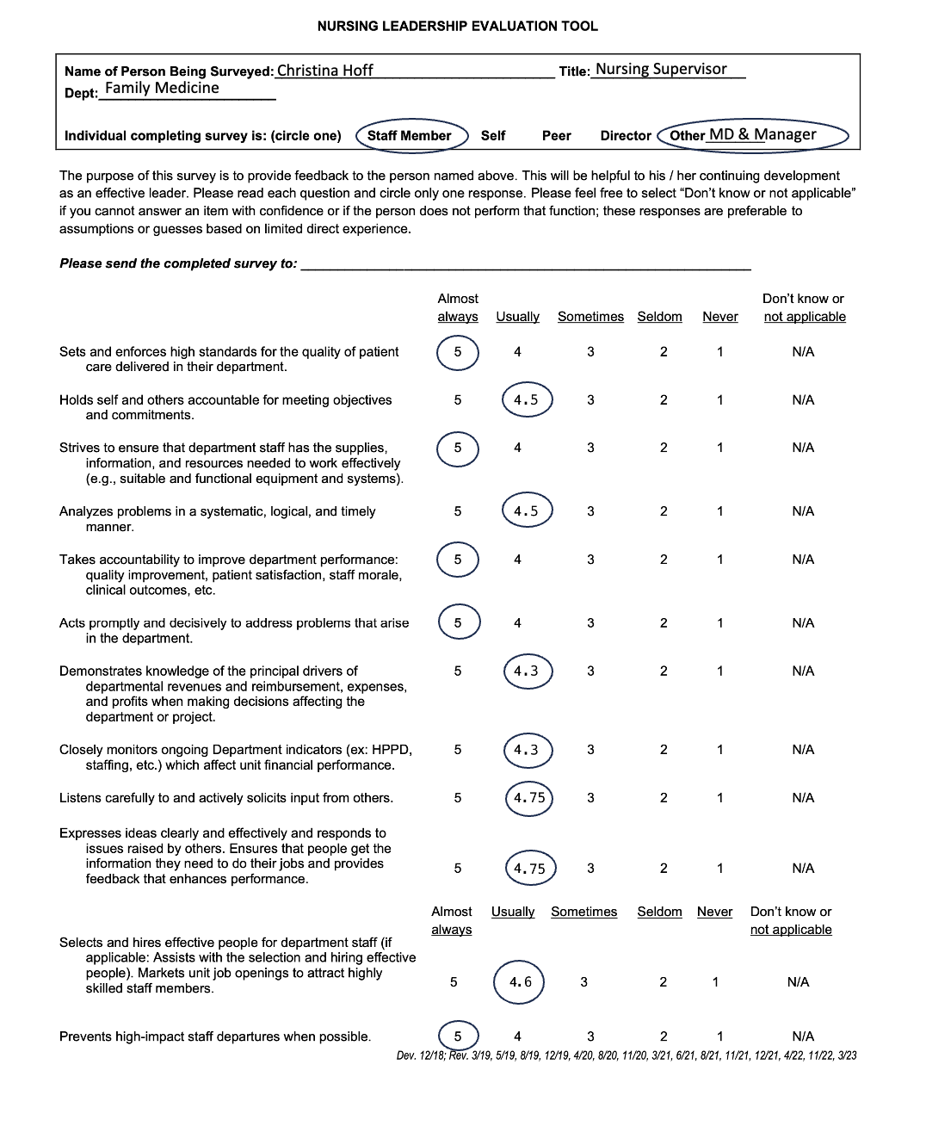
Calculated Mean for 360 Leadership Evaluation Tool
Andy Larson

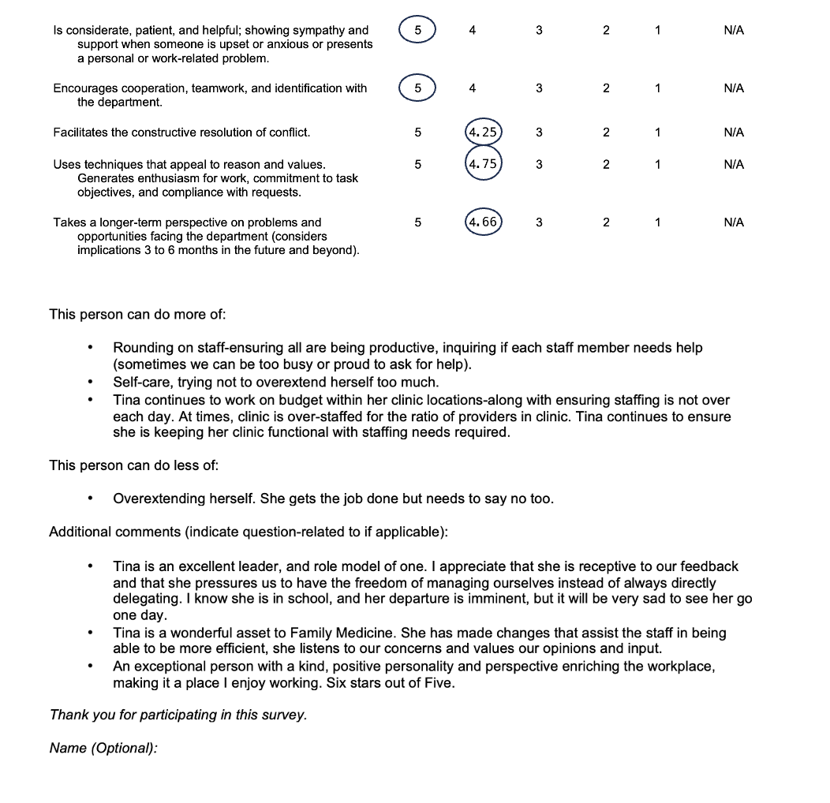

Appendix B
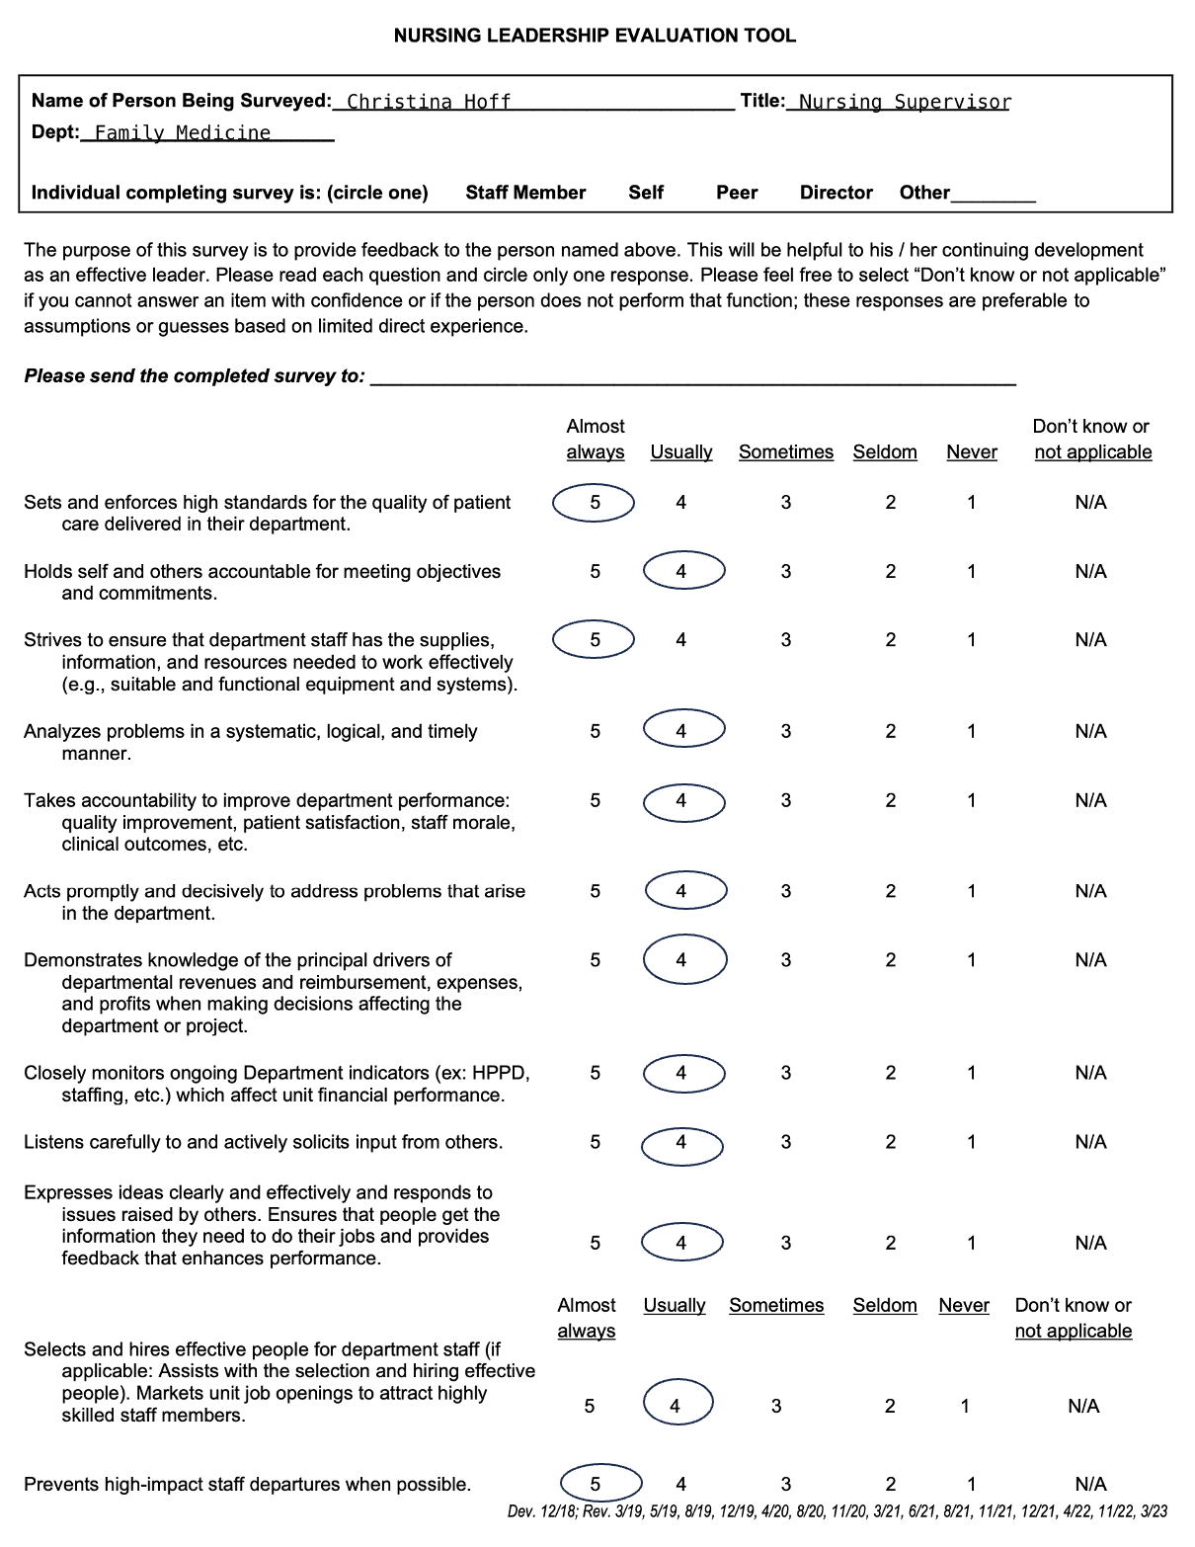
Self-Assessment for 360 Leadership Evaluation Tool
